Parents’ Boarding

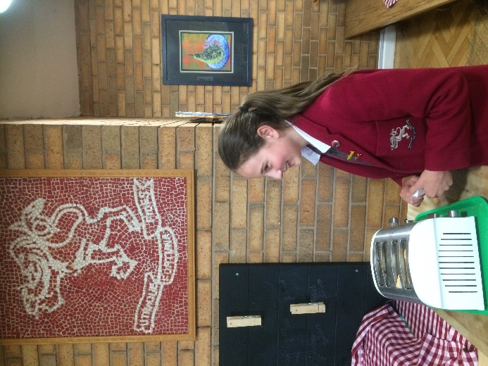
Handbook

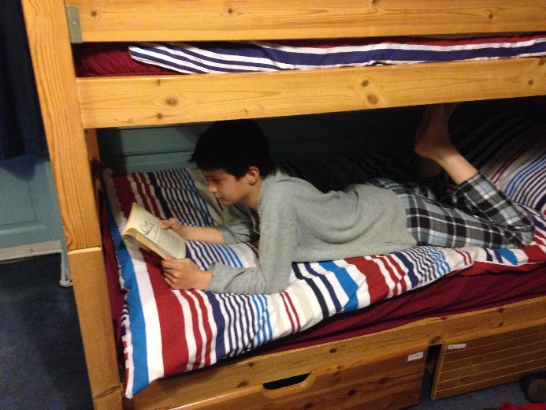
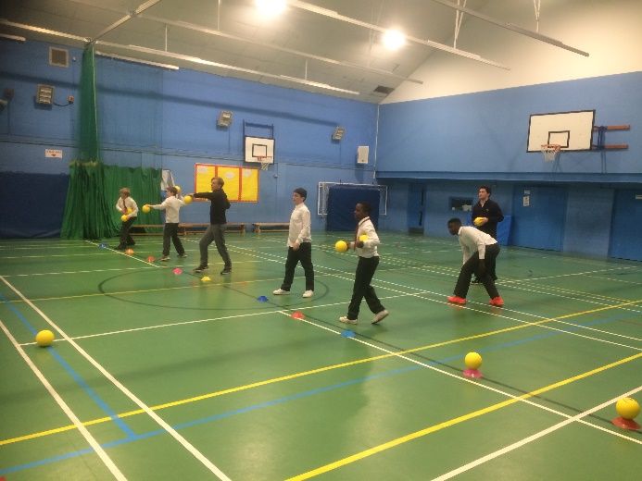
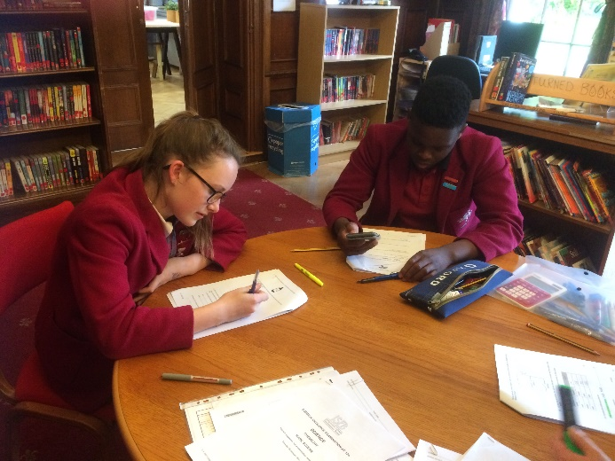
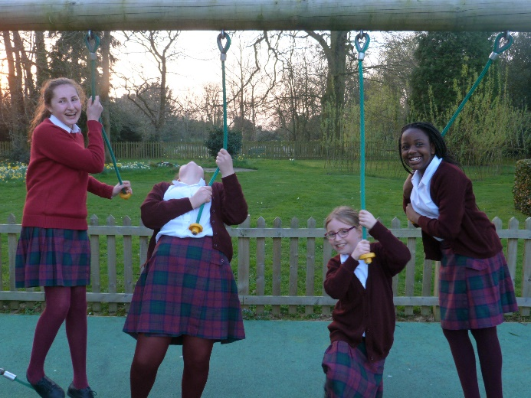

Introduction

This handbook provides a useful guide to boarding for parents. It explains how boarding can benefit the whole family and why we encourage boarding at Edge Grove. We hope that when you have read it and watched the boarding video you will consider your child boarding here. We offer taster nights so that you and your child can get a feel for boarding.

The handbook also gives relevant, basic information for parents whose children are boarding, such as contact details, collection and drop-off times and locations, what to bring, what the dorms are like, what to do in an emergency or if your child requires medication. If there is anything that you still need to know please contact the Boarding Staff, the contact details of whom given in this document.

Welcome from Mr McManus

As Head of Boarding and a parent of children at Edge Grove School I would like to welcome you and your family to our boarding community. Edge Grove has a long history of boarding and believes that the holistic atmosphere of the school is greatly influenced by our boarding provision. Boarding is offered to those pupils (from the UK or overseas) who wish to board either as weekly (6 nights per week) or on a flexi-boarding basis. The boarders are housed in the original building of the school in dormitories organised by age. The Headmaster and the Head of Boarding both live in the building along with their families, as does the Housemistress and other resident members of the boarding staff, all of whom work to maintain the smooth running of the boarding community and to enhance the quality of life of the pupils whilst they are in school.
Children are given the opportunity to experience a broad spectrum of activities and experiences which encourage them to reach their potential, both individually and within our community. Our main aim in the boarding house is to ensure that the pupils get the support and pastoral care that they need so that they are happy, enabling them to flourish in the school and boarding community. We encourage our children to take responsibility for themselves, others and their environment. This supports the development of leadership, teamwork and a real community feel amongst the boarders. I look forward to your son or daughter joining our happy boarding family.

Contents
Why Boarding? 1
Boarding Ethos and Aim 1
Boarding Options 1
The Boarding Team 1
Contacting the boarding team 2
What Happens in Boarding? 3
Evenings 3
Mornings 3
Saturday Mornings 4
Evening Activities and Projects 4
Friday Nights 4
Prep and Reading 5
Sleeping 5
Keeping in touch 5
What to bring 6
Clothes and things 6
Electronic Devices 7
Pocket Money 7
Food and Drink 7
The Boarding Floor 7
Collection and drop-off 8
Collection 8
Signing out 8
Drop-off 9
Emergencies and Medical 9
Emergency contact details and guardians 9
Medical emergencies 9
Assistance in the night 10
Medication 10
Fire Procedures 10
Pastoral Support 10
Boarding Buddies 11
Enjoying the Experience 11
Boarding Fees ………..………………………………………………………………….………….11

Why Boarding?

Boarding is one of the great strengths of Edge Grove and is very much at the heart of the school. It’s a great experience for pupils who love boarding and being with their friends, and it helps parents who are busy or live a long way from school. Many parents work away from home and have term-time commitments which make boarding a safe and stable option, allowing parents to be confident that their children are being well cared for. Similarly, some families live quite far from school and boarding can reduce travel time for the whole family, allowing children to make the most of their time at school.

It is widely accepted that boarding supports the development of life skills and independence, as well as giving children the opportunity to try a range of activities and supporting academic study. Perhaps most importantly for the children, boarding often leads to the development of strong, life-long friendships.

Boarding at Edge Grove is designed to be enjoyable, caring, supportive and nurturing. We want all pupils who stay in the boarding house, whether for a boarding taster night or as a weekly boarder, to love their time here and to leave with fond memories.

Boarding Ethos and Aims

For boarders at Edge Grove, our ethos is to reflect the stability of a caring home and to provide the wealth of activities made possible in a boarding community. We aim to:

- Develop the whole personality of our students through activities, games, support for academic work and our ‘boarding forums’
- Encourage concern for others, unselfish attitudes, self-confidence and adaptability
- Prepare pupils for senior school and possible full time boarding

Boarding Options

At Edge Grove, we offer:

- Weekly boarding – 5 to 6 nights from Sunday evening to Saturday morning
- Flexi boarding of 1 to 4 nights per week
- Occasional boarding

The Boarding Team

We have an experienced and caring boarding team who will support the boarders throughout their time in the boarding house. They are always available to talk, to help with routine matters and to create an enjoyable environment.

Mr Brian McManus is the Head of Boarding and Housemaster. He has worked at Edge Grove for over 8 years and has had a variety of roles including Director of Sport, Activities Coordinator and Lower School Teacher, all of which have helped to prepare him for life as the Head of Boarding. He has also taken a number of groups on expedition week and school trips to Sri Lanka and St Vincent.

Miss Dolly Grounds is the Housemistress and has been in her current role for over five years. Miss Dolly, as she is known, keeps the boarding house well organised and ensures that the children have everything they need. The boarders know that Miss Dolly is always there to listen and care for them. She knows the pupils well and they always know that they can go to her if they need anything.

The boarding team also comprises a number of academic staff who support the evening activities and help the boarding team to get the children to bed.

The Gap students and Graduate Gaps are all invaluable members of the team. The boarders love spending time with the Gaps and can often be found chatting to them, asking for their help, playing games or reading together.

Contacting the boarding team

You can get in touch with the main members of the boarding team at any time. There are a number of ways to contact them depending on the situation.

For general enquiries about boarding or to communicate about non-urgent matters it is possible to telephone the school on 01923 855724 between 8am and 6pm. If no one is available to answer your call they will be given a message and will return your call as soon as possible.

Alternatively the Boarding Staff can be contacted via boarding@edgegrove.com or on their school email addresses (bmcmanus@edgegrove.com; dgrounds@edgegrove.com). We recommend emailing boarding@edgegrove.com or all the boarding staff if an email requires fairly urgent attention, that way whoever is on duty will receive the email.

In order to contact staff in an emergency after 6pm please use the Duty Mobile number
07793 546 233. We request that this is only used for emergencies as staff are busy looking after pupils from 6pm each evening.

Members of the boarding staff are always happy to arrange meetings to discuss any aspects of boarding.

What Happens in Boarding?

The boarding evening is packed with things to do but we also ensure that pupils have time to relax and rest. For that reason we allow the pupils to choose from a selection of activities in the evening and also make time to read, talk and play. There is a routine, to make sure we fit everything in and get the children to bed on time, however, just like at home, we try to be flexible. One thing we are pretty strict about is bedtimes!

Below you’ll find an outline of the boarding routine and also descriptions of the activities and projects that the children can get involved in.

Evenings

4.15pm | Activities and prep sessions. We encourage boarders to take part in a variety of activities but also to do an appropriate number of Prep Sessions for their age. This should be discussed and arranged with tutors.  Pupils boarding on a Friday night can choose to go upstairs at 4.15 and change into home clothes and relax or watch television in the common room. Once the new boarders’ kitchen is up and running we’ll be busy baking too.
6.00pm | Supper starts promptly at 6.00pm because there is a lot to do in the evening! After supper the boarding staff will give boarders the activity choices for the evening and give out any notices.
6:30pm | Evening Activities. We aim to make the activities varied and encompass sports, team games, music, crafts and other relaxing pastimes. Details of the sorts of things on offer are on page 4. Pupils may also choose to do their prep, revise or read, and make and receive phone calls.
7.30 pm | ‘Grub’ and dorms. We know how hungry growing children get so we provide a snack before bed. Fruit, milk and bread/toast are always on offer. After grub boarders can go upstairs to shower and enjoy some time in their dorms. Children may chat, play games, read books and watch television.
8.15-9.00 pm | Year 3 and 4 boarders are in bed for some quiet reading at 8.15pm and go to sleep at 8.30pm. Year 5 and 6 boarders are in bed for reading at 8.30pm and go to sleep at 8.45pm. Year 7 and 8 boarders are in bed for reading at 8.45pm and go to sleep at 9.00pm.

Mornings

7.00-7.15am | Wake up, wash, dress and tidy dorms. Early risers can read a book or watch the news.
7.45 am | Breakfast is varied but always includes a good selection of hot food, cereal, toast, juice and tea, to ensure that boarders start the day well fed and energetic.
8.15 am | Registration takes place. Pupils collect their bags and ensure that they have everything ready for the school day. We encourage older pupils in particular to be independent and be responsible for ensuring that they have everything they need for the day.

Saturday Mornings

Saturday mornings follow the same format but are a little more relaxed.

8.15am | Wake up, wash, dress and tidy dorms
8.45am | Breakfast
9:30-10:00am | Boarders collected

Evening Activities and Projects

Activities are organized for boarders during the week that make full use of the school’s facilities including the sports hall, IT facilities, music room, art department, food technology room, library, assembly hall and the school grounds. These exclusive activities enhance the school and boarding experience and bring a sense of community to boarding.

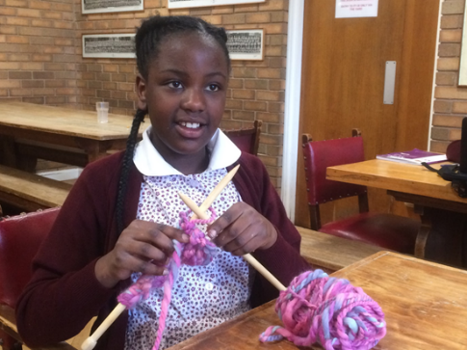
Activities include badminton, music practice, basketball, art, dodge ball, sewing, table tennis, card and board games, cricket, football, IT, cooking, lego modelling, drawing, swimming, time in the adventure playground. Suggestions for other activities are always welcome.

We also encourage the children to get involved in a ‘project’ that they can share with family and friends. This might be a craft project, a written project such as a boarding diary, a charity project, lego construction or anything that the Boarding Staff agree to! Not only is it a lot of fun but also gives the boarders a useful skill.

Friday Nights

Friday nights are a bit special because there is no school the next day so we can be a bit more flexible. We regularly organize special activities or outings such as trips to Megajump, Topgolf and the cinema. Watching films and eating popcorn is a firm favourite with the boarders! We have also had evenings organized by Josh Rose that include bouncy castles and team games. We welcome occasional boarders on a Friday night so that they can experience boarding and to make it a bit different for regular boarders who may wish to invite other friends.

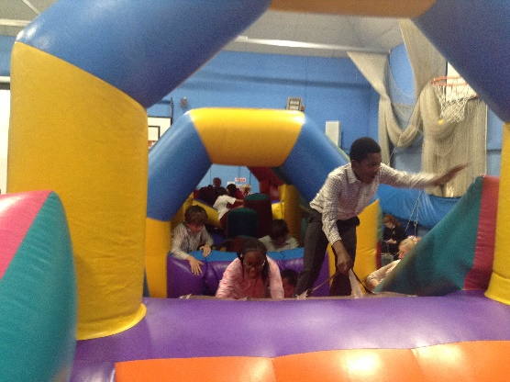

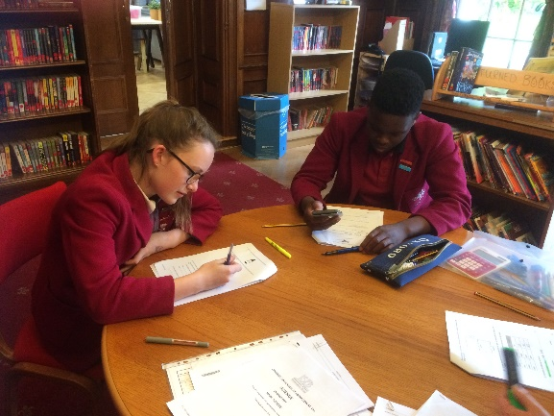
Prep and Reading

All children should have their reading book with them when they board. They read silently for 15 minutes before bedtime. In addition we try to listen to weekly boarders read, we also read stories to the boarders and read around the room.

Pupils are encouraged to attend school prep sessions but may also feel that they need time in the evenings to complete their work. Pupils are given the opportunity to work after supper if they need to but the Boarding Staff will also try to ensure that all pupils get a good balance of prep, activities and relaxation and will communicate with you and tutors if they are concerned about the amount of time that any pupils spends doing prep.

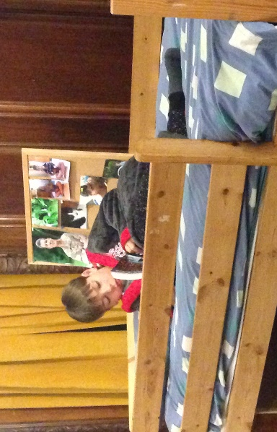

Sleeping

Getting enough sleep is very important and bedtime routines are planned carefully to give a good balance of free time and appropriate rest. After lights out, it is expected that there is no noise. If children are having difficulty sleeping, they should speak to a member of staff. Children sleep in dormitories with other children of their own age.

Keeping in touch

You may be worried about how to keep in touch with your children or how often you can talk to them but there is no need to be because we have lots of ways that you can contact them. We have mobile phones dedicated to the boys and girls floors, as well as a call box. In addition pupils can email their parents through their school email accounts.

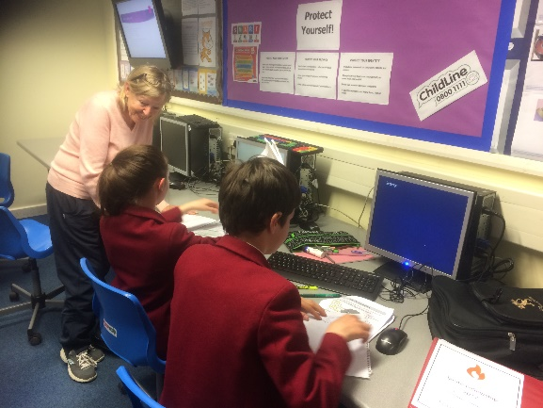
The best times to phone are between 6:30pm and 7:30pm for Years 3 to 6 and 6.30pm to 8.30pm for Years 7 and 8. Please do not phone after 8.30pm because the children will be in bed either asleep or quiet reading.

- Boys phone: 07936 836 307 or 01923 289 929
- Girls phone: 07552 804 505

Boarders can also ask boarding staff to arrange for their parents to call or can make a quick call from the boarding phones and ask their parents to call back. We do everything we can to ensure that boarders can speak to their parents whenever they want to.

It may seem old fashioned but there is nothing like receiving a letter or post card when you board! Post can be sent to the main school address.

Keeping in touch with school life

A weekly information letter is emailed to parents on Mondays. This contains important information regarding all aspects of school life including sports fixtures, trips, visits and other activities that may involve your child. These events may require additional uniform or kit. Please ensure that you read this each week.

What to bring
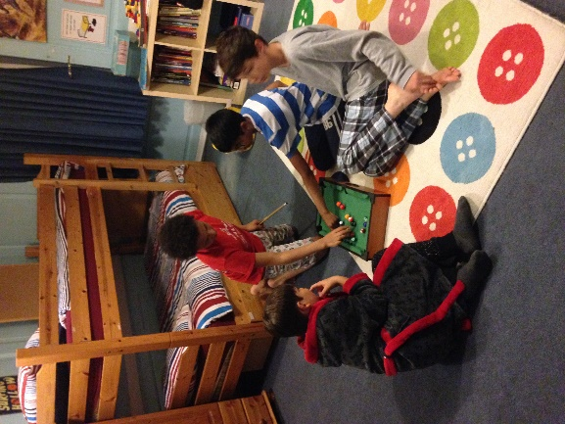

Clothes and things

All boarders will need the following items. All clothes and towels must be clearly named:

- Pyjamas
- Dressing gown
- Slippers
- Towel
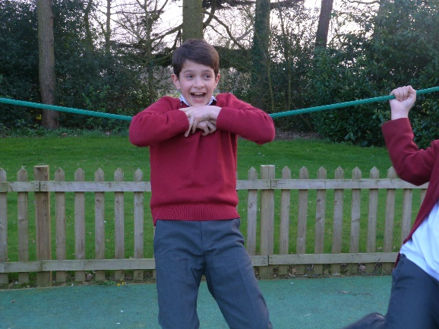
- Wash bag containing: hairbrush/comb, shampoo and conditioner, shower gel, sponge, toothpaste, toothbrush, roll-on/cream deodorant (no aerosols of any kind)
- Shower caps (for girls)
- School uniform/shoes
- Underwear and socks
- A favourite teddy
- Pictures and posters if you like

Duvets/pillows and covers are provided.

Electronic Devices

Any boarders who bring their own phones into school must hand these in to the front office or to the Boarding Team upon arrival.

In a conscious effort to ensure our pupils are protected, any device with a camera or a screen or which can connect to the internet through any means is not permitted at school.

All Year 7 and 8 pupils’ Chrome books are collected by the Boarding staff each evening and charged overnight in the Boarding House.

Pocket Money

Boarders are welcome to bring in a little pocket money for trips, shopping, cake sales and so on. We suggest that boarders bring no more than £50 per term. This should be left with the Boarding staff who will record it in a ledger and give small amounts when required. All pocket money not used will be returned at the end of each term.
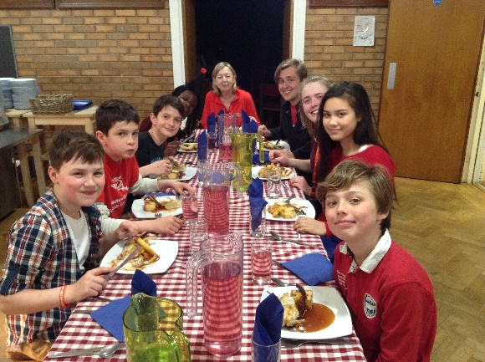

Food and Drink

We ask that boarders do not bring any food or drink into school. We have a number of pupils with allergies and to protect them it is the school policy that pupils cannot bring food or drink to school. There is no need to worry though, pupils never go hungry! Pupils are well catered for and all meals are adequate in nutrition, quantity, quality and choice. We cater for all pupils including those with special dietary, medical and religious needs and boarders are included in the requirement for all parents to complete a full pupil food tolerance profile sheet every year. We regularly review our menus and ask the boarders for their input on what meals they have enjoyed and what they would like added to the menus. Fruit, milk and bread is provided all evening in the dining room and boarding kitchen. There is also a monthly tuck shop and Fair Trade Café where the boarders can buy small quantities of tuck.

The Boarding Floor

If you haven’t visited the boarding floor you may wonder what it’s like. We are very happy to take parents and pupils on a tour of the boarding accommodation at any time. The floor is divided into the ‘girls’ floor’ and ‘the boys’ floor’. Both areas have modern bathrooms with showers. There are three dorms on each floor with between two and 12 beds in each. The boys’ dorms are called North, South and Willow; the girls’ dorms are called Cedar, Beech and Sycamore. The dorms are arranged by age group and the Boarding staff allocate dorms according to age and other relevant factors depending on the mix of pupils.

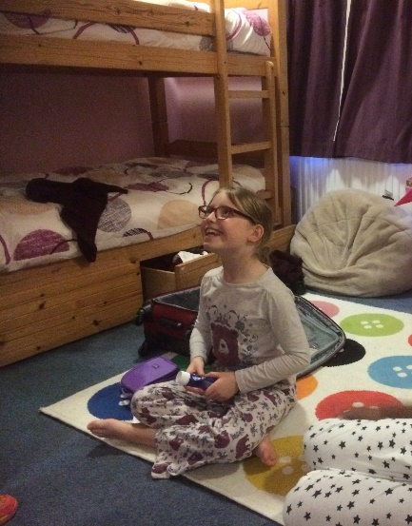
All dorms are newly decorated with insulated curtains, bunkbeds, clothes storage and bookcases. Many of the dorms have soft furnishings and toys. There are televisions for the girls and the boys but pupils must ask permission before watching TV.

Dorm time is a time when pupils can unwind with their friends and make new friends. We try to make it as relaxed a time as possible. Staff and Gaps are always on hand to help the boarders and talk to them. All pupils have showers before bed and can call their parents, read, play, chat and do some prep. This is also a time for dorm discussions and boarding forum meetings.

Collection and drop-off

Collection

Pupils should be collected after school or after their usual activities. Pupils should be signed out from the Astro Turf or in the Headmaster’s Courtyard and their boarding bag collected from under the arches.

Signing out

4.15pm Lower School – Astro turf
Middle and Upper Schools – Headmaster’s Courtyard
5.30pm All pupils - Headmaster’s Courtyard
6.00pm All pupils - Headmaster’s Courtyard
Half term* Lower School – Astro turf
Middle and Upper Schools – Headmaster’s Courtyard
Holidays* Lower School – Astro turf
Middle and Upper Schools – Headmaster’s Courtyard
* Please refer to the school calendar for pick up times.

The boarding staff will be under the arches at Exeats, half term and holidays to speak to parents and help pupils. Should you wish to see the boarding staff at any other time please contact them and they will be happy to meet you.

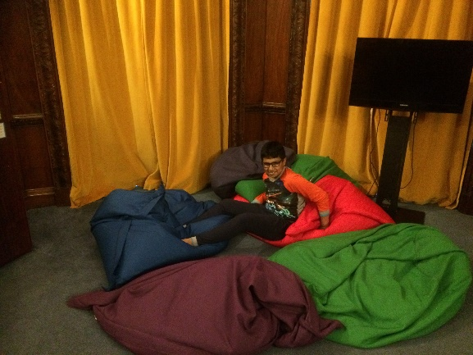
Please note, children can only be collected by parents or official guardians who have been registered with the School. We will not hand over a child to anyone unless we have received an email request (confirmation will be sent to you) and we have seen identification.

Drop-off

Pupils may be dropped off between 6.00 and 7.30pm on Sunday. Please be aware that staff will not be available before 6.00pm. It is possibly to arrange a later drop off but pupils must be back before their usual bedtime. Pupils should be brought to the dining room where they will have a snack and play games before going up to their dorms.

Boarders being brought to school in the morning should leave their bag in the cupboards under the arches. No valuables should be left in the bags. Anything valuable should be handed to the boarding staff or into reception.

Emergencies and Medical

Emergency contact details and guardians

All overseas pupils must have a guardian in the country and within a reasonable distance from the school. In addition we recommend that all parents provide us with an alternative contact in case you are away or unable to come to the school in an emergency. This is vital because, as part of our medical policy, pupils who are seriously unwell or have an infectious illness need to go home. This is partly to reduce the spread of an illness but also because we recognize that many children would rather be with a parent or guardian when they are unwell. Furthermore, hospitals are increasingly requiring parents to attend Accident and Emergency with their children. Whilst we will always take a child to A&E if required it is often necessary for the parent to attend to give consent for treatment.

Overseas pupils must have a designated guardian in the country and close enough to visit or stay with if necessary. Pupils whose parents are in the country but live some way from school may also choose to have a guardian. Knowing that a family member or close friend is nearby can be very comforting for a child.

Medical emergencies

All non UK pupils will need to have private medical insurance. Non EU pupils can now be required to produce their passports to receive NHS treatment. This may need to be paid for as well. Therefore all non UK pupils will need to leave their passports at school. EU passport holders are also required to have a European Health Insurance card (EHIC). This is free but must be applied for by the parents in the home country.
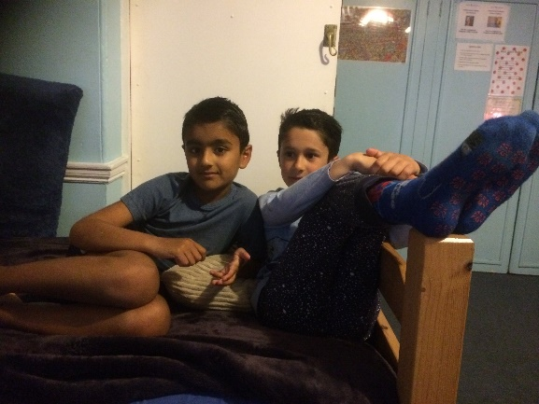

Assistance in the night

If a child needs assistance during the night, the member of boarding staff on duty can be contacted by ringing the buzzer. All new boarders are shown the location the buzzer during their first evening and they know that they can call the duty staff at any time. There is always a female member of staff on duty and a number of other staff available should they be required.

In the event of a child requiring medical treatment in the evening our qualified first aiders will administer the appropriate medication. Appropriate contact will be made to the parents following the incident.

Medication

All medication, whether it is prescription or over the counter, should be handed either to reception or the School Nurse in the morning before registration or to the Head of Boarding/Housemistress upon arrival at school (evenings). All medication must be in the original container accompanied by a ‘Medication Consent Form’ which can be found on Firefly. No medication can be administered without this. Controlled drugs must only be handed to the nurse or the boarding staff to be locked away.

For the medical consent form please use this link: http://firefly.edgegrove.com/medical-information/medication

Please refer to the Medical Policy which can be found on: http://www.edgegrove.com/uploads/asset_file/First_Aid_and_Medical_Policy_-_September_2016_v201609-01.pdf

Fire Procedures

All pupils are shown the fire evacuation procedures on the first night that they board and we have at least two fire drills each term. At these times all the boarding staff and the Head Master are responsible for ensuring that all boarders are safely out of the building. Staff and pupils wait in the Chapel while the fire is investigated.

We know that fire drills can upset children and therefore we do everything that we can to reassure them about the process.

Pastoral Support

The boarders at Edge Grove are fortunate to have a large number of adults to whom they can turn should they have a problem or suggestion. Within the Boarding House, there is a suggestions box where the children can write suggestions and a locked “Worry Box” which is opened regularly by the school nurse. Any worries are dealt with confidentially.

Our Independent listeners are Robert Fletcher (local Vicar) and Sue Barnard. They visit the school on a regular basis and are available to meet with both day pupils and boarders. All pupils can contact them by telephone using a free number. Their telephone numbers and photographs are displayed on boards in the Boarding House and around the school. The boarding staff are always available to talk to children and their families if there are any concerns.

Boarding Buddies

We don’t want any pupils to feel lonely or not know what they are doing when they board at Edge Grove so we assign everyone a boarding buddy. Their role is to help new boarders find their way around and to encourage them to take part in all aspects of boarding life.

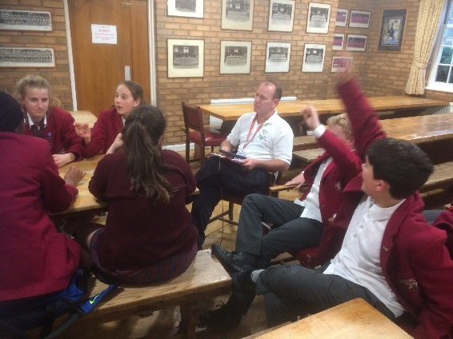
Boarding Forums

In addition to the opportunities for informal communication between boarders and the boarding team in the Boarding House, the children’s views about their lives as boarders are sought regularly through Boarders’ Forums. We currently have a ‘food forum’, an ‘activities forum’ and a ‘tuck team’. The pupil representatives have regular discussions with the boarders and then report to the Boarding or other relevant staff. The ‘tuck team’ is responsible for running the school tuck shop with the Charity Club.

The forums are designed to give the children an opportunity to discuss any issues relating to their lives as boarders, to put their ideas forward for consideration and to raise any worries they may have. Above all, it is vital that boarders feel that they have a voice and that there suggestions are taken seriously.
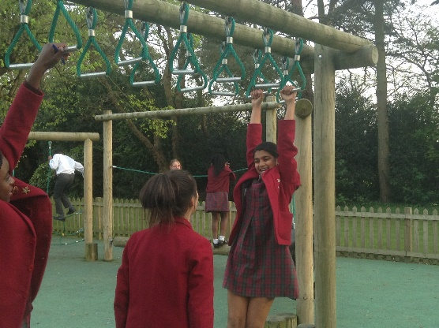

Enjoying the Experience

Above all boarding should be a fantastic experience that Edge Grove pupils remember fondly for the rest of their lives. We hope that your children will join that group.
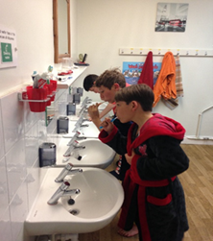

Boarding Fees

For weekly and Flexi boarders, fees are payable in advance and are added to your account. There is the normal notice period of half a term if pupils are going to stop boarding.
In the case of casual boarding, these fees are charged in arrears and added to your end of term account.

