Welcome to Boarding at Edge Grove!

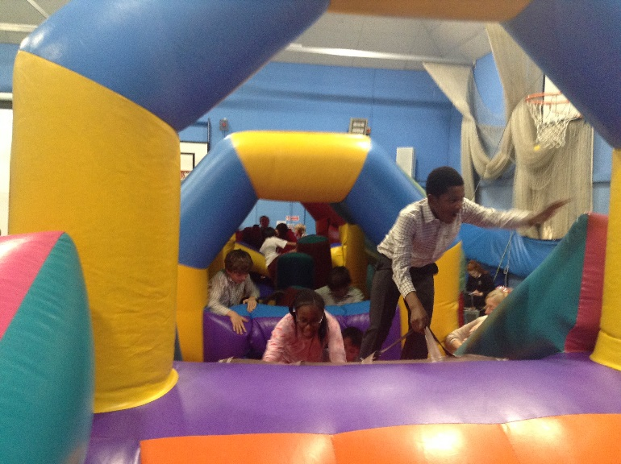

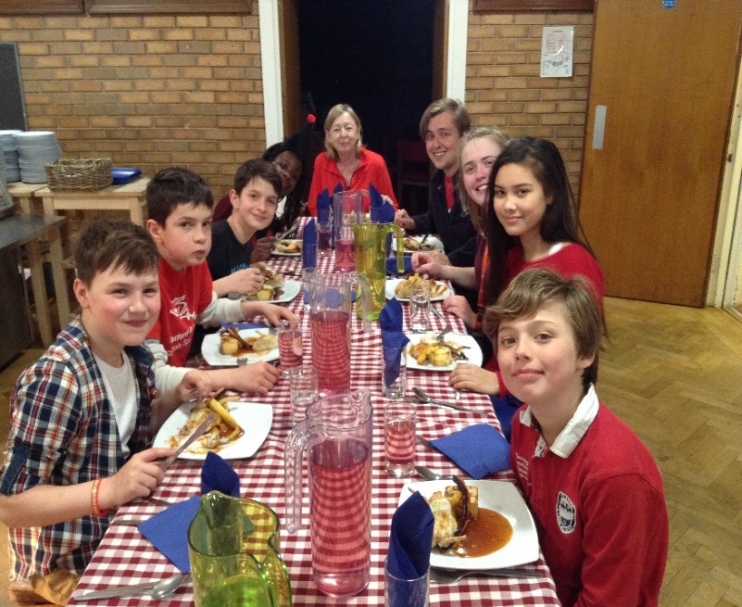

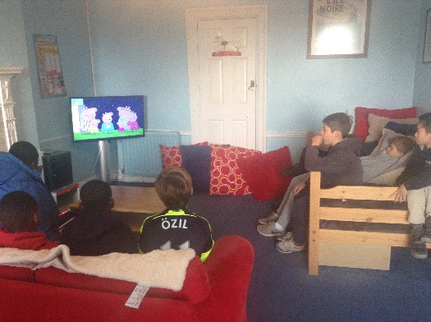

Boarding at Edge Grove
Meet the boarding team

Whether you are new to boarding or have boarded before, we understand that it is quite a daunting experience when you first arrive. You will probably have many questions about what your life as a boarder at Edge Grove will be like.
Your parents have got their own Boarding Handbook which has lots of information in it. This guide is written for you and hopefully, it will answer most of your questions. Please read it before you come and then you can refer to it whenever you want once you are here. Mr and Mrs Evans and all the Boarding staff will answer any questions you may have along the way. The boarding staff consist of Mr McManus (Housemaster and Head of Boarding), Miss Dolly (Housemistress), together with our GAP students. To contact us email boarding@edgegrove.com.
One of the best things about boarding is that you will be with here with lots of other boys and girls from several different age groups.
You will be well looked after and we wish you a happy and successful time with us.
What should I bring?

The two most important things to get ready are your school uniform and a favourite teddy! Here is a simple list to get you started:

• School uniform/shoes
• Underwear/Socks
• Towel
• Dressing Gown
• Slippers
• Wash bag (soap and shampoo, etc.)
• Toothbrush/Toothpaste
• Hairbrush/comb
• Shower cap (girls)
• Mufti

If you are here for three nights or more, you can also bring games, a letter writing set, writing materials, reading books, photographs, a diary or address book, and a few pictures to make your bed area as homely as possible.
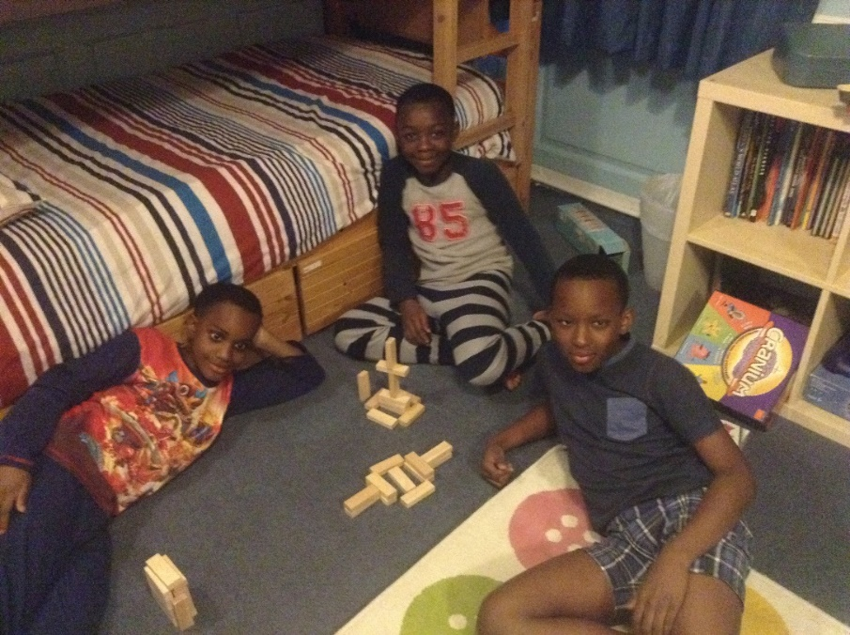

Anything that you do bring should be clearly marked with your name so that you don’t lose it. Try not to bring in anything too expensive or too important to you. Things do get damaged by accident so the motto is, if it’s really valuable to you, leave it at home.
If you are not sure if you will be allowed to bring a particular possession, just ask your parents to contact the school to find out before you come. We have a large supply of books and game activities so you don’t need to bring your own.
What happens in the Mornings and Evenings?

Here is a description of the basic morning and evening routines. This is to give you an idea about how a typical day works. You are not expected to remember everything so do not be too alarmed. When you arrive you will be given lots of help.

Wake up and get ready routine
From 7.00am all the dormitories are woken up by the House Staff. It is time to get dressed into your school uniform (unless otherwise instructed).
You are responsible for getting dressed, making sure your hair is brushed and tied back properly and that your shoelaces are tied.
Once you are dressed you will then make your bed and tidy your under-bed drawer. We want you to keep your dorms tidy and we have a reward system of pebbles if you do it well – these add up to special treats.
Every week we change the sheets and duvet covers. We will help you do this but we really want you to be able to do it yourself.
7.45am is breakfast time. The Boarding Staff will check that everything is tidy and send everyone down for breakfast.
Then you can get into the school timetable, starting with a form tutorial at 8.25am.
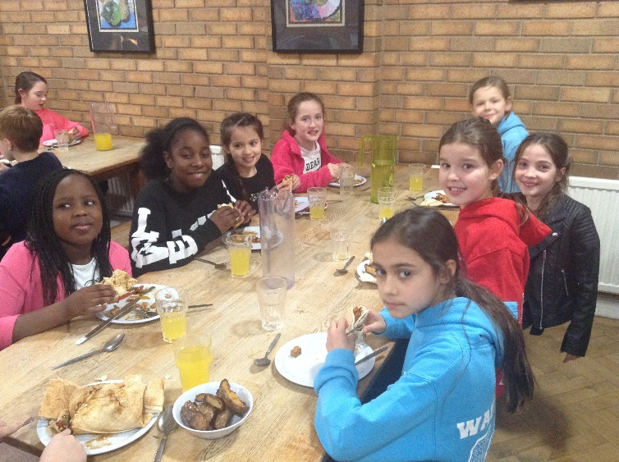

At the end of the School day
Your tutor period finishes at 4.15pm. After this there is the activity period. There is a very wide range of activities to choose from and the boarding staff will help you
(and your parents!) decide what you want to take part in. If you don’t do an activity, you will go to a supervised Prep session to finish your homework. Everyone needs to do at least three prep sessions a week.
At 5.30pm we all meet in the yard to go upstairs to change and then down to the dining room for supper at 6:00pm.
After supper there is plenty of time for activities, these include fun games, arts and Crafts, going to the sports hall and playing outside (in the summer term), doing music practice or just spending a little time with friends.
Time for bed

Depending upon which Year group you are in, bedtime routines are as follows:

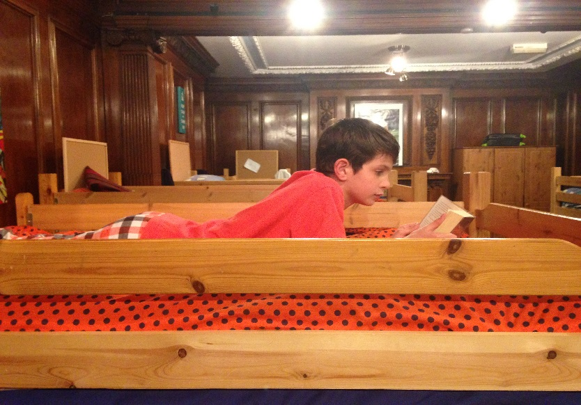
You will have a snack, known as ‘Grub’, at 7:30pm before going upstairs into your dormitory.
Years 3 & 4
8.15 p.m. Quiet reading**
8.30 p.m. Lights out
Years 5 & 6
8.30 p.m. Quiet reading**
8.45 p.m. Lights out
Year 7 & 8
8.15 – 8.45 TV or games
8.45 p.m. Quiet reading**
9.00 p.m. Lights out

Sometimes bed times might be a little later e.g. school events, football/rugby matches on the television, social events or hot chocolate and biscuits.
** This is a time for the boarding staff to read you bedtime stories or your dorm may listen to a story CD or you may read quietly.

The Dormitories

BOYS - South and North
GIRLS – Cedar, Beech and Sycamore

We will arrange the dormitories so that you will sleep with children of a similar age to you.
In each dormitory you will ﬁnd:
• Poster boards
• Bookcases with reading books
• A drawer under your bunk bed
• A clock
In North and Cedar there are televisions which can be watched on some (not all) evenings and weekends.

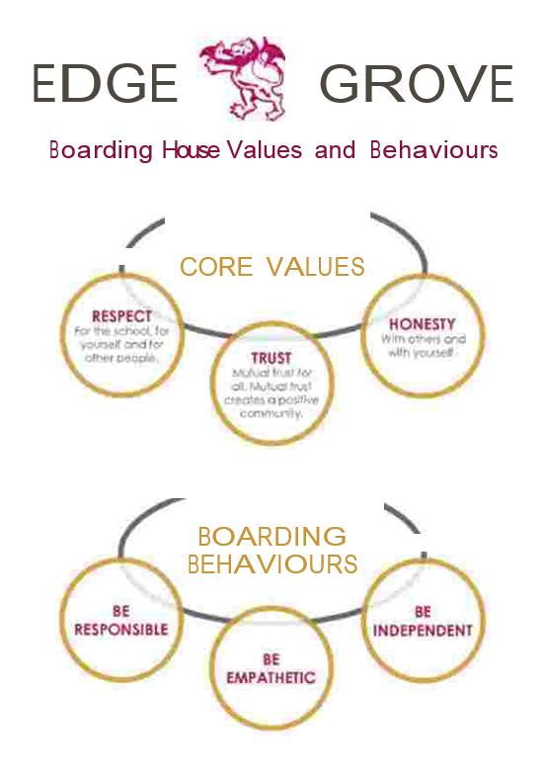

Boarders’ Routines

Younger Boarders’ Routine
At bedtime, you come upstairs and prepare your clothes for the next morning. For weekly boarders clean clothes can be found on your bed in your dormitory and should be put neatly into your under-bed drawer. Clothes that you have worn but do not need washing on that day should be neatly folded and also put into your drawer before you go for showers. Your red jumper must always be placed by your drawer along with your shoes in case there is a fire drill during the night. After having a shower, put on your pyjamas, brush your teeth and comb your hair. (Everyone showers every night – you can have a shower in the morning as well if you’d like one.)

Older Boarders’ Routine
This routine is very much the same as the younger boarders. However as an older boarder, you will be expected to show more independence and take more responsibility for yourself. House staff will be around to help.
When all your jobs have been completed you will have free time until quiet reading and ‘lights out’.

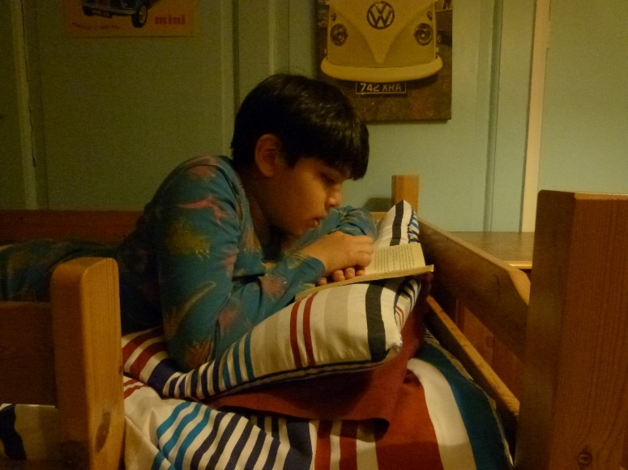
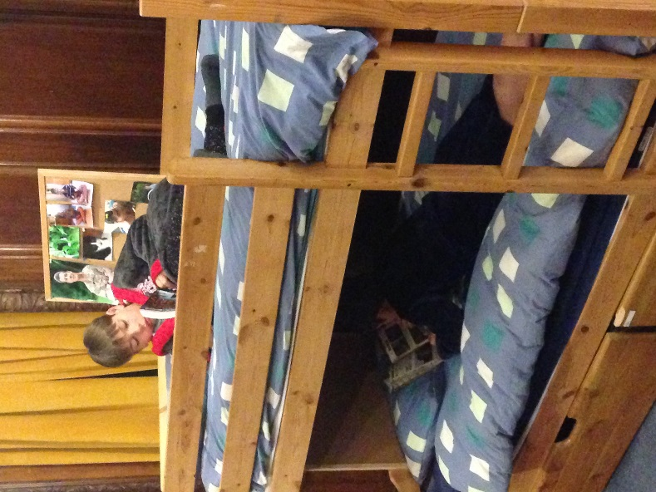
Meal Times
All meals are taken in the dining room
Breakfast
7.45 a.m. (Monday to Friday)
8.45 a.m. (Saturdays only)
Morning break
10.40 a.m.
(Morning break is served near the courts for the Lower School and in the schoolyard under the arches for Upper School)
Lunch
(Monday to Friday)
12.45 p.m. Lower School
1.10 p.m. Upper School
Afternoon break
4.05 p.m.
(Afternoon break is held under the arches)
Supper
6.00pm
We give you plenty of delicious, freshly prepared food so you can choose a healthy diet. Of course this will include all your favourites!
The menus are available on the website so your parents can see what you are eating.
If you find that you are still hungry after supper then ‘grub’ (fruit, milk, biscuits etc.) is available in the Dining Room before going up to bed.

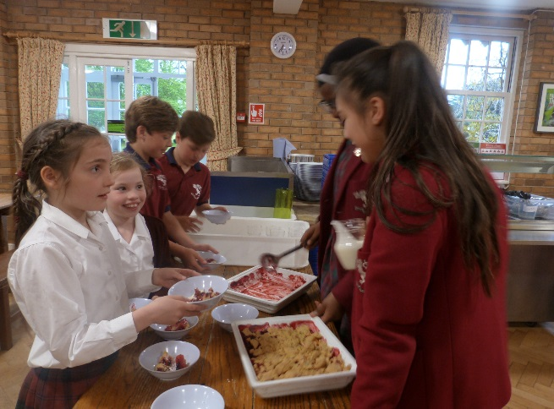
General Information
Communication
Don’t forget to let your parents and friends know that they can write and e-mail you whilst you are at School. You will get an email address when you arrive. They can find out about school events and see pictures on the school website www.edgegrove.com. As a boarder it is very important that you keep in regular contact with your family and friends.
Getting in touch with home is really easy. If you want to call home just ask a staff member and we will arrange it (It might not happen right at that moment.)
Family and friends can also call you. They call the duty mobile and the staff will arrange everything else. Quite a few boarders have a regular phone time each week which makes getting in touch even easier.
You can also Skype your parents – although this isn’t usually a regular thing. Our Skype address at school is ‘edgegrove’. Telephone calls are great but don’t forget that your parents will really love receiving a nice long letter from you too!
Happy Birthday!
If your birthday is during term time you will get a cake after supper to share with all the other boarders. We will probably embarrass you by singing to you as well! Before bed time your dormitory will also get to have hot chocolate and some fun time in the boarding common room.
Exeats
These are weekends when school is closed. They last from Friday afternoons where pick up is at 6pm from the Front Hall, until Sunday evening or Monday morning. The weekends are usually spent with parents, guardians or friends.
Boarders Kitchen
This is where boarders can meet up, chat, make a drink, cook toast or have a bowl of cereal together with the boarding staff.
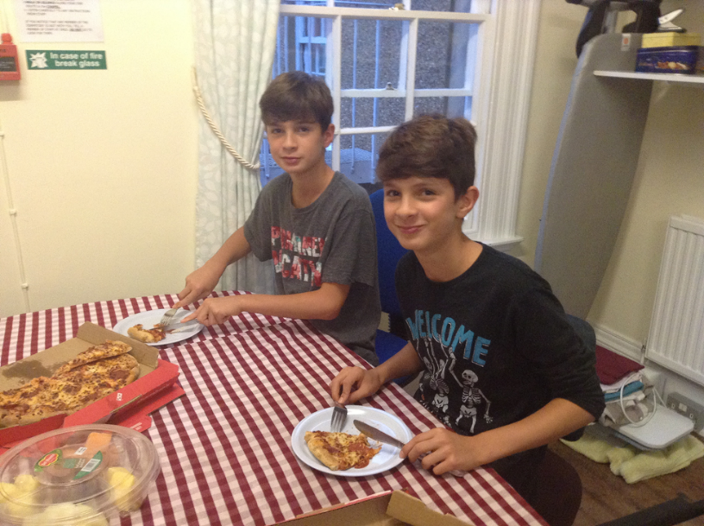

Willow
This room has a TV/DVD a Wii, games and books. It is where small groups of boarders can meet, chat and play during the evenings. The boys watch the news in here each morning before breakfast.

School Nurse’s Surgery
There are three main surgery times. These are morning break, lunch break and afternoon break. If at any time during the day you are feeling poorly, you can see the School Nurse (with permission and a note from a teacher). When ill, you may stay in the sick bay and be looked after by the School Nurse. The School Nurse is available during the day and the House staff are available in the evenings and overnight. The school doctor comes in every week.
If you feel unwell during the night or have a problem of any kind, you can get help from the member of staff on duty by pressing the duty buzzer. It doesn’t matter what hour of night it is, staff will be happy to help. There is a whole team of people to care for you in the main house overnight.

PROBLEMS?
If at any time you are worried about something, the best course of action is to talk to somebody about it. A problem shared is a problem halved!
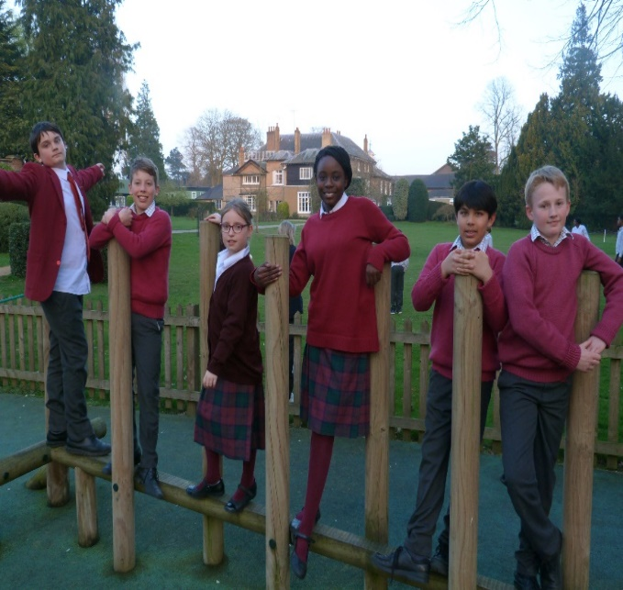
There will always be someone here you can talk to. Whoever you speak to will either be able to help you to solve your problems or suggest who you should speak to. Have a look at the ‘Circle of Care’ on the next page.

Fire Drills
At least twice a term, you will have to take part
in a night-time fire drill. In case of a fire the
duty team are responsible for ensuring everyone
is awake and out of bed, have their red jumpers
on, and that the windows of the dorm are closed.
Staff will assist in clearing the dorms. You must
follow instructions and you should stay together
with other members of your dorm. It is extremely
important that everyone is silent and remains calm.
This is in order for you to hear any instructions issued. When you first arrive, you will be told what you must do and where to go in case of fire. The Chapel is the meeting point.
Circle of Care
Any Pupil at Edge Grove should know that any problems, complaints or suggestions will be taken seriously... and the School would like to hear about them.
How can you let us know what is worrying you?
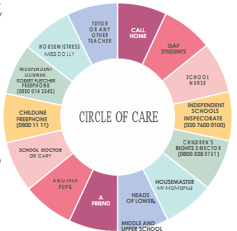
- By talking about it to anyone in the Circle of Care – or by writing it down if you find that easier. There is a “Worry Box” in the boarding house where you can post your thoughts. You can put your name on the note or write anonymously.
- You can do this by yourself, through your parents or through a friend.

- You can let your dormitory representative know and it can be talked about at the dorm meetings.

- You will not get in to trouble for raising a suggestion or concern.

What activities and clubs are available to boarders?
There are so many exciting things to do at Edge Grove

Here are some of the activities you can do between 4pm and 6pm
Choir | Art Club | Cookery
Band | Crafts Club | Sports Hall Activities
Athletics | Computer Club | Hockey Club
Science Club | Swimming | Outdoor Games
Technology Club | Art Scholarship | Archery
Soft Ball | Fencing | Strings Group
Drama Club | Chess Club | Squash
Street Dance | Cricket nets | Taekwondo
Indoor Netball | Lacrosse | Rugby Skills
Tennis | Horse-Riding | Golf
Mandarin | LAMDA

(Dependent on the season and availability)
QUESTIONS ANSWERED

1. Are we allowed to bring tuck?
Unfortunately pupils are not allowed to bring in any food to school due to allergies. Boarders are regularly given treats so there is no need.
2. What are GAPs?
GAPs are young adults who have just left school and who join us for a year. We hope they will be like big brothers and sisters to you looking after you, playing games and helping with work. Don’t forget though that they are members of staff.
3. When do we strip our beds?
Once a week usually. We help you make your bed in the evening.
4. Do we have lockers or places to put our stuff?
Every boarder has a drawer for personal things. We have a lockable box for valuable things – although it’s probably best to leave them at home. Flexi boarders keep things in their bag in their room.
5. What are the different kinds of boarders?
We have three types of boarders at Edge Grove:
Weekly boarders stay at school during the week and go home either on Friday night or Saturday morning.
Flexi boarders stay one, two, three or four regular nights each week.
Casual boarders sometimes stay at school. They aren’t really part of the boarding house but we hope they enjoy the experience and board more often and more regularly.

Finally
We hope that this booklet has put your mind at rest about some of the worries you may have had about boarding at Edge Grove and what to expect. If you are unsure about anything when you arrive, just ask. We are always here to help you.
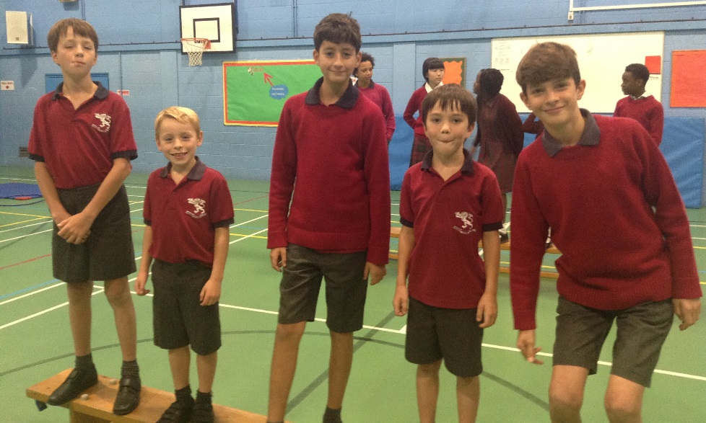
Mr McManus, Miss Dolly and the Boarding Team

